Status in bold: Draft, In Review, Official |  | Doc. No. 3xxxxxx P10 000 Version 00
Update Status and colored text, some inside [Bookmarks]. Refresh Ctrl A, F9.
For more instructions (eg about content of chapters) click on the ¶ icon on the standard toolbar of MS Word.

- Doc No. is the assigned document identifier from Metaphase. (US: request from NA-Doc Control )
- Version is the official metaphase release (00 for initial release to Metaphase
- Project Code is the charge number (i.e. METS)
- Launch describes the appropriate project revision (Concept 2.5, Kampai V1, Ethernet V3)
- To update automated fields, Select all text Ctrl A, Update F9, Save file, Close file and Open file to see updated fields
- Release Official document to Metaphase. (US: refer to electronic approval described in “Documentation Control – Procedures, Policies, Standards” 31002443)

Project Code : xxxxxx Launch: xxxxxx

Technical Specification

M80 Massive firmware upgrade

 | Department : | Name : | Date
Author : | IOCC | Jie DING | Jun/25/14
Reviewed by : | IOCC | Jianguang WANG | Jun/27/14
Approved by :

Proprietary Notice : This document contains proprietary information of Schneider Automation., and neither the document nor said proprietary information shall be published, reproduced, copied, disclosed or used for any purpose other than consideration of this document without the express written permission of a duly authorized representative of said company.
¶

Document modifications
Ver. | Date  mm/dd/yr | Author | Modifications
00.00 | Jun/25/14 | JIE Ding | Creation
00.01 | Jun/25/14 | JIE Ding | First Draft
00.02
.
.
.
00.
All changes and in this document are marked as shown here.

Template file name: Technical_Spec_tempV02.doc Template identification in Metaphase : 35003470 QSY 000 Version 02
Note: A facsimile of this template may be used but shall contain the document title, status, major content headings, complete document identifier and approvals.

Document Control: Forward this document to Metaphase via the local Documentation Services organization.

Table of Contents

1. Issue 4
2. Solution 4
3. Architecture Overview 4
4. GLOSSARY OF TERMS 5
5. Detail Implementation 5
6. Notes 10
7. Appendix 11
7.1 Logins & Passwords 11
7.2 File System 11
7.3 Multicast packet which MFUS send 11
7.4 Uni-cast packet which other M80 device send to MFUS 11
7.5 Upgrade Report 12
7.6 Massive Upgrade Time 12

Issue
Firmware upgrade for mass of M80 devices cost too long time.

Solution
Upgrade one of the M80, let this M80 to setup a FTP server, and inform other M80 via UDP multicast packet to download the firmware via FTP protocal. The devices which already completed firmware upgrade will also join in providing the new firmware. So there will be lots of the firmware provider to help the upgrade be rapid.

After all devices completed the firmware upgrade, the first M80 will scan all devices to generate a report and allow user to download the report and import to excel.

Below document describes the detailed.

Architecture Overview
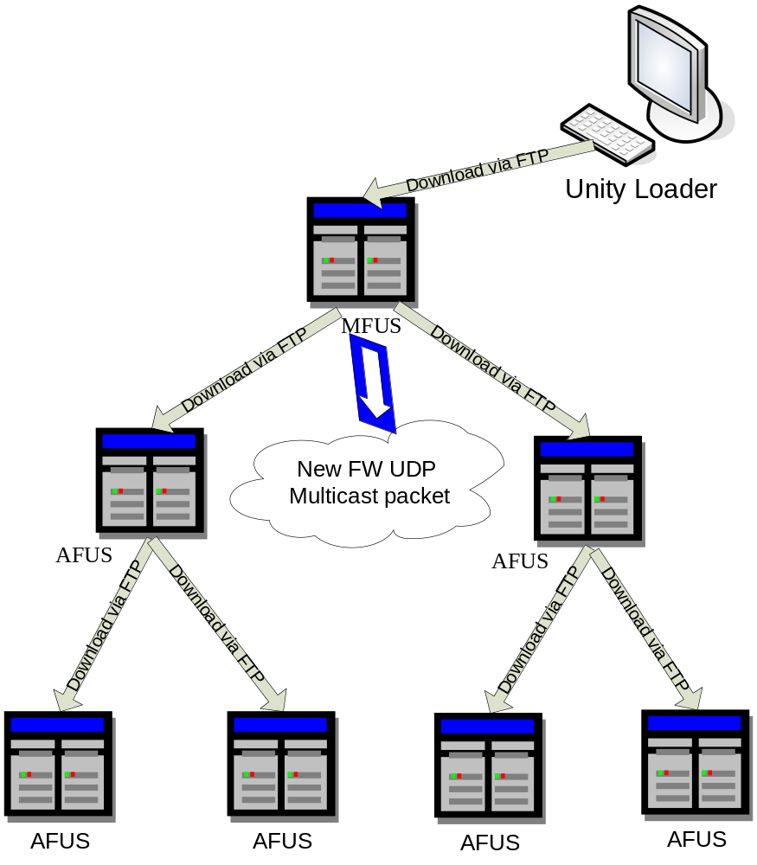

GLOSSARY OF TERMS

Term | Definition
MFUS | Main firmware upgrade server
AFUS | Assistant firmware upgrade server
UDP | User Datagram Protocol
Loader | Designs the component inside a CPU or Option controlling the firmware upgrade

Detail Implementation

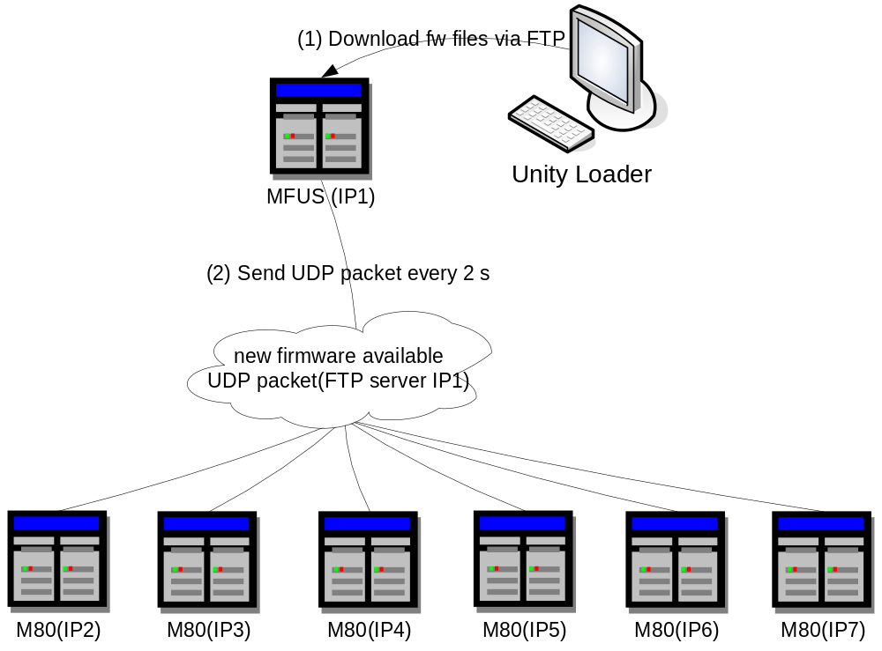
- Upgrade 1 M80's firmware via Unity Loader. This M80 will be called main firmware upgrade server(MFUS).
- After get FW files from unity loader via FTP, MFUS send "new firmware available " multicast packet to inform all M80 devices to get FW files from AFUS list(at first only MFUS located in AFUS list).

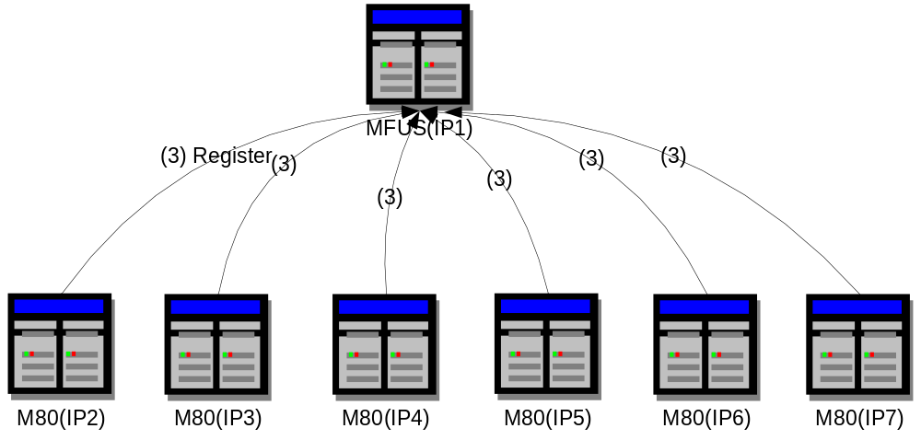
- When other M80 devices receive "new firmware available " packet, it check upgrade fw version with runtime version, if not match,it send packet to register in MFUS and ready to download new fw from random FTP server in AFUS list.

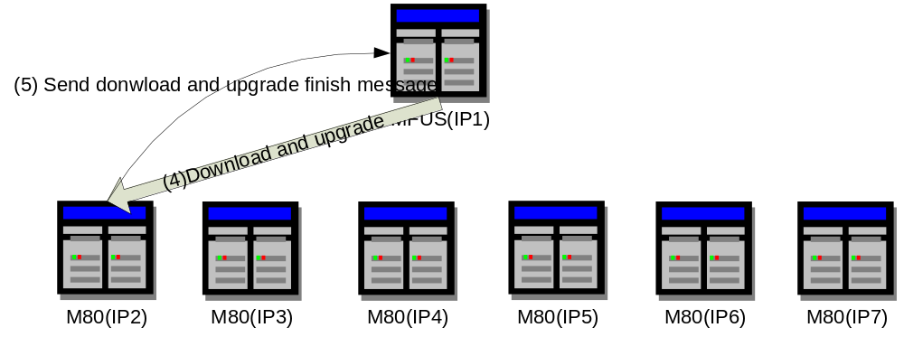
- One FTP server only support 1 M80 to connect and download FW, after download ,M80 process upgrade with local loader.
- Once one M80 device upgrade finished,it send packet to inform MFUS that it can act as an AFUS.
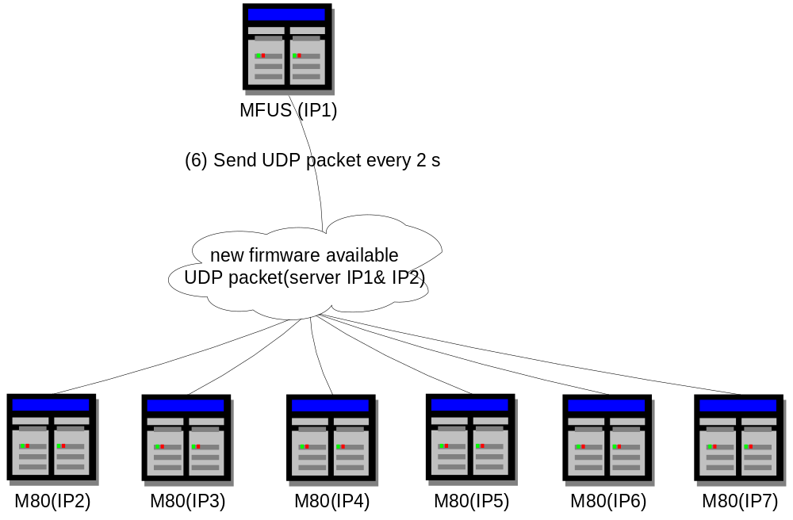
- MFUS renew AFUS list in “new firmware available” package and inform other M80 dervice to get files from new AFUS list.
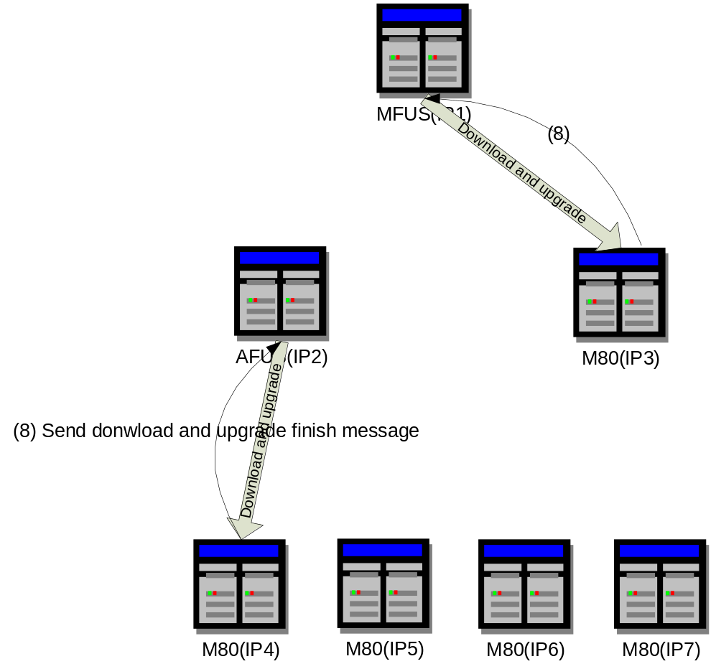
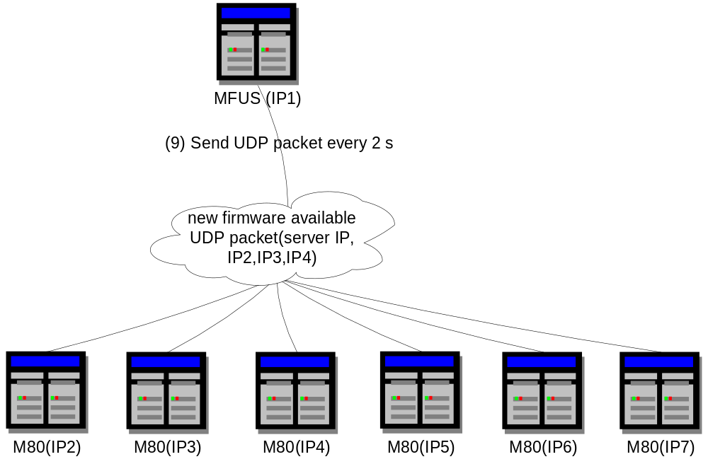
- Repeat step 4,
- Repeat step 5
- Repeat step 6
- Repeat step 4
- Repeat step 5

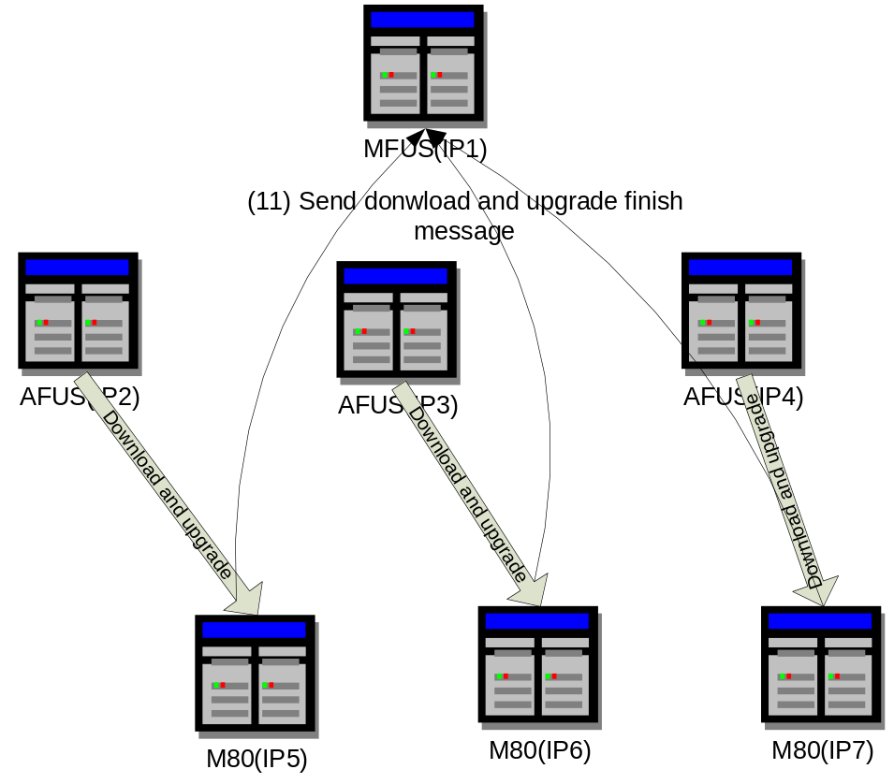
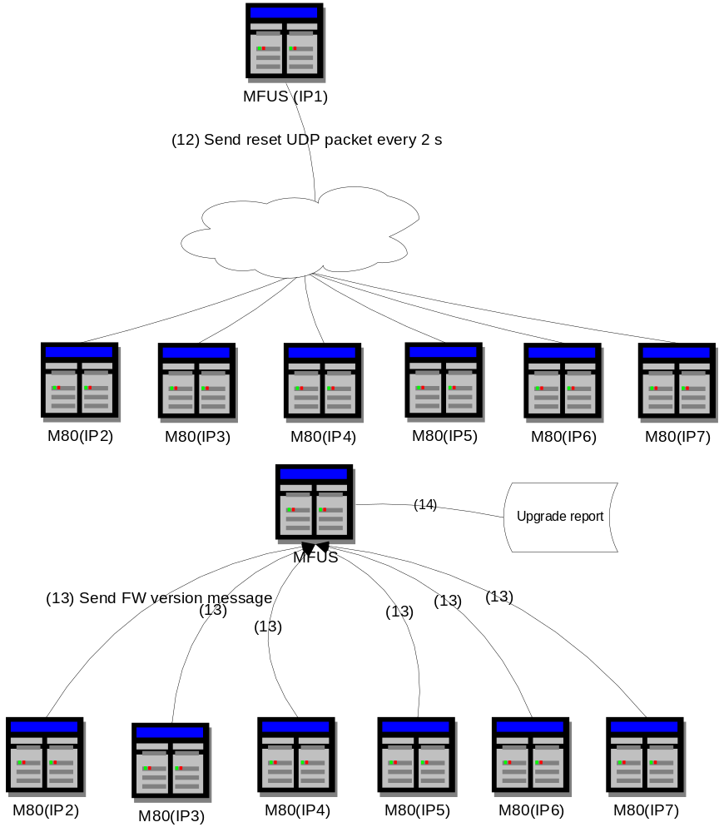
- After all registered M80 devices upgrade finished, MFUS send reset UDP packet to reset and waiting M80 device reboot.
- Check if FW version upgrade successfully and generate report to record upgrade status.
- At last MFUS upgrade and reset itself ,the whole massive fw upgrade complete.

Notes
- FTP server function should be enabled before using massive fw upgrade function.
- Massive fw upgrade function is disabled when default, it should be enabled before use.

Appendix

Logins & Passwords

Login : loader
Password: fwdownload

File System
Item | Description
/RAM0/ldr/Firmware/Device/fw.ini | CPU Executive description file
/RAM0/ldr/Firmware/Device/vxworks.img | CPU Executive file
/RAM0/ldr/Firmware/Device/HSC.ini | HSC Executive description file
/RAM0/ldr/Firmware/Device/HSC.img | HSC Executive file
/RAM0/ldr/Firmware/Device/DDM.ini | DDM Executive description file
/RAM0/ldr/Firmware/Device/DDM.img | DDM Executive file

Multicast packet which MFUS send
The "new firmware available " packet should include below information:
    - New firmware version
    - Hardware ID
    - Firmware file name
    - Ftp username
    - Ftp password
    - MFUS IP address
    - AFUS IP address list.
This Multicast packet is UDP packet, MFUS should send it every 2s until all devices completed the firmware upgrade and checked upgraded FW version after reset.

Uni-cast packet which other M80 device send to MFUS
- Register
- Download
- Upgrade
- FW_OK
- FW_NOK
Each message should be sent continuously until MFUS send ACK back.

Upgrade Report
User can get massive upgrade report from “/usr/FWUpgradeReport.bin”.

Item | Size
Upgrade M80 device IP address | 4 bytes
Upgrade status | 4 bytes

Upgrade status:
Status type | Value
REGISTER | 2
DOWNLOAD FINISHED | 4
UPGRADE FINISHED | 6
UPGRADE OK | 8
UPGRADE NOK | 10

Massive Upgrade Time
Test device: 4 M80 devices (1 MFUS, 3 AFUS)
Test tool: unity loader
Total time: 6~7 min

Time | Action
3:45 | unity loader start download
3:45 | 3 AFUS registered
3:46 | 3 AFUS download finished
3:48 | 3 AFUS program finished
3:49 | reset 3 AFUS
3:51 | 3 AFUS reboot and read their FW version (Because test devices are boot from Ethernet, it need more time than boot from Flash for 3 M80 device.
3:52 | upgrade and reset MFUS
3:52 | whole upgrade process finished ,unity loader can be closed

